Chapter 11

Family, Friends, and Fellowship:  
 Motivation at the Micro and Meso Level.

By: Jennifer Griggers and Elliot Norquist

Delta State University, College of __, Department of__

Learning Objectives:

By the end of this chapter, you’ll be able too:

·   Understand the different parenting styles and support.

·    Define the concepts of motivation in friends, family, and fellowship using intrinsic vs extrinsic.

- Understand the different strategies used in the Five Ecological Systems

-Understand the Self-Determination Theory.

**Introduction**

Humans are social beings and strive to be accepted in society. Family, friends, fellowship and other social groups are important for our overall well-being, physically and psychologically. Our participation in groups serves a social and emotional purpose, but they also help us learn how to be accepted into a larger society. These factors also influence cognitive development in the way we behave, what we believe, and how we perceive the world around us.

American psychologist Urie Bronfenbrenner was critical of previous theories of child development. He recognized there are multiple aspects of a developing child’s life that interacts with and affects the child. His work looked beyond individual development, taking into account wider influencing factors and the context of development. He suggested that the environment of the child is a nested arrangement of structures, each contained within the next called **The Five Ecological Systems.**

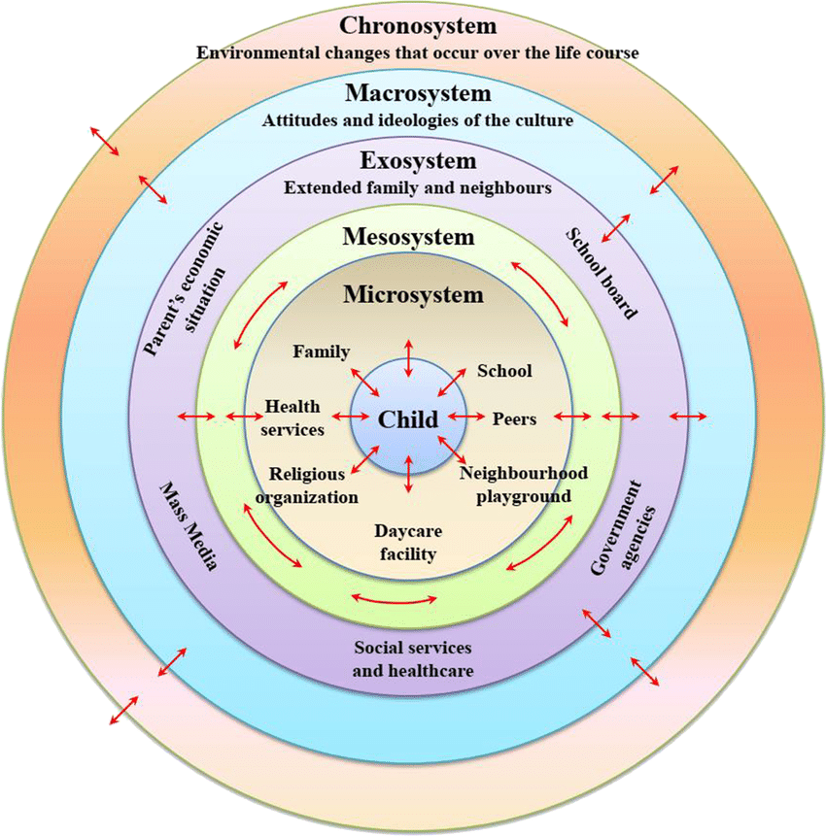

* Different levels of the Five Ecological stages. Mcleod, S. (2023, April 21).

The **Microsystem** is the first level of Bronfenbrenner’s theory and are the things that have direct contact with the child in their immediate environment, such as parents, siblings, teachers and school peers. Relationships in a microsystem are bi-directional, meaning the child can be influenced by other people in their environment and is also capable of changing the beliefs and actions of other people too. The reaction of the child to individuals in their microsystem can influence how they treat them in return. The interactions within microsystems are often very personal and are crucial for fostering and supporting the child's development.

The **mesosystem** encompasses the interactions between the child's microsystem, such as the interactions between the child’s parents and teachers, or between school peers and siblings. For instance, if the child’s parents communicate with the child's teachers, this interaction may influence the child’s development. Essentially, a mesosystem is a system of microsystems.

**Self-determination theory** suggests that all humans have three basic psychological needs- autonomy, competence, relatedness- that underline growth and development.

* **Autonomy** refers to the feeling one has choice and is willingly endorsing one's behavior. The opposite experience is feeling compelled or controlled in one's own behavior.
* **Competence** refers to the experience of mastery and being effective in one's activity.
* **Relatedness** refers to the need to feel connected and a sense of belongingness with others.

The social environment (e.g friends, family, teachers, etc..) can promote or get in the way of peoples striving by the extent to which they support a person’s basic psychological needs.

* Autonomy is supported by attempting to grasp and acknowledge the person’s wishes, preferences, and perspective.  Conveying understanding of their point of view, providing rationale for engaging in a behavior, and providing choice on how to behave.
* Competence is supported by providing the person with optimal challenges and opportunities ( specific goals that are challenging but not overwhelming), encouraging their sense of initiation, providing structure to mobilize and organize behavior and providing relevant feedback.
* Relatedness is supported when others are involved and show interest in the person’s activities, are empathic in responding to their feelings and convey that the person is significant, cared for, and loved.

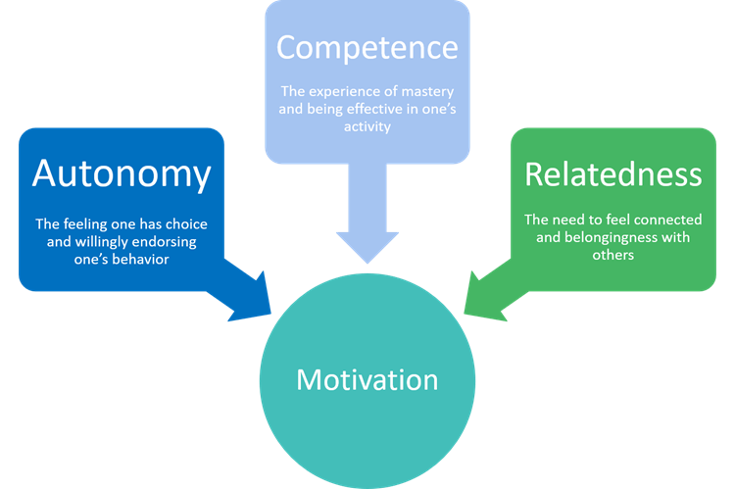

* *Image from Our approach*. Self-Determination Theory of Motivation

Intrinsic Vs. Extrinsic Motivation

**Intrinsic motivation** refers to actions that are driven by internal rewards. This motivation to engage in a behavior arises from within because of the inherent satisfaction of the activity rather than the desire for a reward of specific outcome. The three main elements of intrinsic motivation are autonomy, purpose, and mastery. People are intrinsically motivated when they can act independently, feel that their efforts matter, and gain satisfaction from becoming more skilled.

* Examples of intrinsic motivation
* Participating in a sport because you find the activity enjoyable.
* Cleaning your room because you like tidying up
* Solving a word puzzle because you find the challenge fun and exciting.
* Studying a subject, you find fascinating

**Extrinsic motivation** is when we are motivated to perform a behavior or engage in an activity because we want to earn a reward or avoid punishment. You will engage in behavior not because you enjoy it or because you find it satisfying, but because you expect to get something in return or avoid something unpleasant.

* Examples of extrinsic motivation
* Participating in a sport to win awards.
* Cleaning your room to avoid being reprimanded by your parents.
* Competing in a contest to win a scholarship.
* Studying because you want to get a good grade.

In the context of friendship, intrinsic motivation might involve the enjoyment of spending time with a friend, the fulfillment of sharing experiences and perspectives, or satisfaction of providing emotional support. Extrinsic motivation, on the other hand, involves engaging in an activity for external reward such as social status, material goods, or recognition. In the context of friendships, extrinsic motivation might involve seeking out friends for the sake of networking, social validation, or access to resources. While both intrinsic and extrinsic motivation can play a role in friendships, researchers have suggested that intrinsic motivation is more closely associated with positive outcomes, such as greater well-being, satisfaction, and longevity in friendships.

Religious affiliations are often motivated by a combination of intrinsic and extrinsic factors. Intrinsic motivation in religious affiliations might involve a deep sense of spiritual fulfillment, a desire to connect with a community, or a personal commitment to moral or ethical values. Extrinsic motivation is religious affiliations might involve seeking social status, adhering to cultural or family expectations, or gaining access to resources and networks. While both intrinsic and extrinsic motivation is associated with greater religious commitment, spiritual well-being, and positive psychological outcomes. However, the relationship between intrinsic and extrinsic motivation in religion can be complex, individuals may experience changes in their intrinsic and extrinsic motivation over the course or their religious journey.

Intrinsic motivation in parenting might involve a deep sense of love and connection with one’s children, a desire to foster their growth and development, or a personal commitment to nurturing and guiding them. Extrinsic motivation in parenting might involve seeking validation from others, adhering to cultural or societal expectations, or gaining recognition for one’s parenting skills. Both intrinsic and extrinsic motivation can impact parenting practice and outcomes, with research suggesting that parenting styles that prioritize warmth, responsiveness, and support are associated with positive outcomes for children. However, relying solely on extrinsic motivation can lead to a focus on external outcomes, such as achieving academic or athletic success, rather than the development of a strong parent-child relationship. Ultimately, the balance between intrinsic and extrinsic motivation in parenting is unique to each individual and can be influenced by a range of factors, including cultural and societal norms, personal values, and life circumstances.

Familial Bonding: Role of Parenting Style and Support

Parental acceptance refers to “extent which parents intentionally foster individually, self-regulation, and self-assertion by being attuned, supportive, and acquiescent to childs special needs and demands” (Baumrind, 1991). Parental demandingness refers to “ the claims parents make on children becoming integrated into the family, by the maturity demands, supervision, disciplinary efforts and willingness to confront the child who is misbehaved.” (Baumrind, 1991).

Crossing both these dimensions, four basic patterns of parenting styles should be considered (see table 1)

**Table 1. Patterns of parenting styles (Ballantine, 2001)**

|  |  |  |  |
| --- | --- | --- | --- |
| **Authoritarian Parenting** | **Authoritative Parenting** | **Permissive**  **Parenting** | **Uninvolved Parenting** |
| High demandingness/control and low acceptance/responsiveness.  Engagement is strictly adult-centered. These parents often fear losing control over the children, and they discourage open communication | Moderate demanding/ control, and acceptance/responsiveness. Open communication, trust and acceptance and encouragement of psychological autonomy are typical in this pattern. | High acceptance/ responsiveness but non-demanding. These parents lack parental control. | Neither responsive nor demanding. These parents often fail to monitor or supervise the children's behavior. They are uninvolved. |

The authoritarian, authoritative, and permissive parenting styles were originally identified and defined by Baumrind (1997, 1991) in a study. Baumrind (1967) found that preschool children raised by authoritative parents are the best adjusted. They are cheerful, socially responsible, self reliant, achievement oriented and cooperative with adults and peers. Children of authoritarian parents tended to be moody and seemingly unhappy, easily annoyed, relatively aimless and not very pleasant to be around. Children of permissive parents were often impulsive and aggressive. They tended to be more controlling and self-centered, rebellious, rather aimless and quite low in independence and achievement.

The worst developmental outcomes were associated with a neglectful, uninvolved type of parenting. Children of neglectful parents are notable for behavioral problems such as aggression and frequent tantrums.

As children move into school, peer and community contexts the parent-child relationship change.

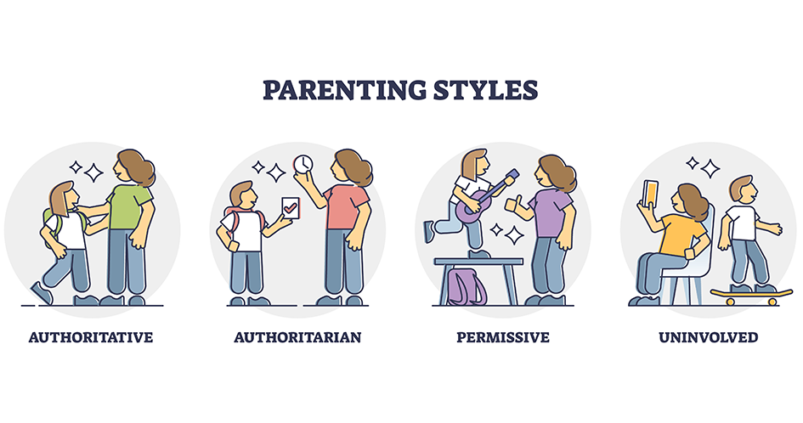

* Example of different parenting types in action.

Studies have shown that supportive parenting is associated with greater familial bonding, while unsupportive or neglectful parenting can lead to weakened family bonds. Additionally, positive family communication and spending quality time together are important factors in fostering family bonds. Overall, parenting style and support are important factors in the development of family bonding, and families who prioritize those aspects tend to have stronger and more fulfilling relationships.

Social bonding: **Affiliation motivation** and **intimacy motivation**

Social bonding is an essential aspect of human development and well-being. It involves forming connections with others and maintaining these relationships over time. Two important motivations that drive social bonding are affiliation motivation and intimacy motivation. Affiliation motivation refers to the drive to form connections with others based on a shared sense of identity or interest. Individuals who are high in affiliation motivation tend to seek out social groups and activities that align with their values and interests. This motivation is often driven by a desire for social support, validation, and sense of belonging. Affiliation motivation can be seen in a variety of contexts, from joining a sports team or club, to participating in online forums or social media groups. For many individuals, affiliation motivation is an important source of social support and a way to form meaningful connections with others.

Intimacy motivation, on the other hand, refers to the drive to form close, personal relationships with others based on emotional and physical closeness. This motivation is often associated with romantic relationships, but also can be present in close friendships or familial relationships. Individuals who are high in intimacy motivation tend to value emotional intimacy, trust, and physical affection in their relationships. They may prioritize spending quality time with loved ones and sharing their thoughts and feelings openly. Intimacy motivation can be a powerful source of connection and support, but it can also be challenging as it involves vulnerability and risk of rejection or hurt.

Both affiliation and intimacy motivation are important drivers of social bonding. While affiliation focuses on shared identity and interest, intimacy focuses on physical and emotional closeness. Understanding these motivations can help individuals form more meaningful connections with others and foster positive relationships over time.

Discussion:

* How do different parenting styles impact motivation and relationships with the family?
* What role does autonomy play in fostering positive relationships within relationships with family, friends and fellowship?
* How do micro and meso level dynamics correlate in creating relationships?
* How can an understanding of self-determination theory inform our approach to motivating individuals within families?
* In what ways can we lack autonomy impact the quality of relationships within families and other relationships?
* How can the principles of motivation be applied at both the micro and meso levels to foster positive relationships and support within these relationships?

Key terms:

* **The Five Ecological Systems. - different levels of influence that shape an individual's development, including micro, meso, exosystem, macro and chronosystem**
* **Microsystem- immediate environment that an individual experiences daily, such as family, peers, school and neighborhood. These settings impact the individual and shape their development.**
* **Mesosystem- refers to the connections between different microsystems, such as the relationship between a child’s school and family. The mesosystem influences the individual’s development through the interactions and connections between different microsystems.**
* **Self-determination theory- psychological theory that describes the motivation behind human behavior. The theory proposes that individuals have basic psychological needs for autonomy, competence, and relatedness, and these needs must be fulfilled for individuals to experience optimal motivation and well-being.**
* **Autonomy- refers to the need for an individual to feel in control of their own decisions and actions. It involves having the freedom to make choices that align with one’s own values and interests.**
* **Competence- refers to the need for an individual to be capable and effective in their actions and pursuits. It involves having skills, knowledge, and resources needed to achieve one’s goal.**
* **Relatedness- refers to the need for an individual to feel connected and valued by others. It involves having supportive relationships and feeling a sense of belonging within a community.**
* **Authoritarian- refers to a parenting or leadership style that is characterized by strict rules and punishments, with little to no input or negotiation from those being led.**
* **Authoritative- refers to a parenting or leadership style that is characterized by setting clear expectations and boundaries, while providing support, guidance and feedback.**
* **Permissive- refers to a parenting or leadership style that is characterized by few rules and consequences, with little structure or guidance provided.**
* **Uninvolved - refers to parenting or leadership style that is characterized by a lack of involvement and attention towards those being led, with little to no emotional support or guidance provided.**
* **Affiliation motivation- refers to the drive to form connections with others based on a shared sense of identity or interest.**
* **Intimacy motivation-refers to the drive to form close, personal relationships with others based on emotional and physical closeness.**

Work Cited

Baumrind, D. (1991). The influence of parenting style on adolescent competence and substance use. The Journal of Early Adolescence, 11, 56-95. http://dx.doi.org/10.1177/0272431691111004

Ballantine, J. H. (2001). *The sociology of education: a systematic analysis.* 2nd ed. Englewood Cliffs, N.J., Prentice-Hall.

Joseph, M. V., & John, J. (2008). Impact of parenting styles on child development. *Global Academic Society Journal: Social Science Insight*, *1*(5), 16-25

Mcleod, S. (2023, April 21). *Bronfenbrenner's ecological systems theory*. Simply Psychology. Retrieved April 22, 2023, from https://www.simplypsychology.org/bronfenbrenner.html

*Our approach*. Self-Determination Theory of Motivation - Center for Community Health & Prevention - University of Rochester Medical Center. (n.d.). Retrieved April 21, 2023, from https://www.urmc.rochester.edu/community-health/patient-care/self-determination-theory.aspx#:~:text=Self%2Ddetermination%20theory%20suggests%20that,is%20willingly%20endorsing%20one's%20behavior.